LO3 – Solve simultaneous linear equations using Gauss-Jordan elimination and matrices
Refresher:
Given 2x + 3y = 7 and -7x - 3y = 10
- Both represent lines; can plot to see where they intersect; can solve for x, y where they cross
- Possible result: cross at one point, parallel (no crossing), same line (always intersect)
Solved by:
- Graph (rough point of intersection)
- Add/subtract equations
- Comparison
- Substitutions (e.g. change 2x + 3y = 7 into 2x = 7 - 3y, then x = 7/2 - 3/2y, and then substitute for x into the other equation)
Fine for two unknowns; what if we have more equations and more unknowns?
Note: number of equations must match number of unknowns
Consider the following system of equations:
2x + 4y + 6z = 46
3x + 12y + 12z = 102
4x + 5y + z = 28
We would like to solve using a controlled process that can applied to any three equations.
This system of equations can be written as a matrix equation (multiply them out to see that they are the same):
$$\left[\begin{matrix}2 & 4 & 6 \\ 3 & 12 & 12 \\ 4 & 5 & 1\end{matrix}\right]*\left[\begin{matrix}x \\ y \\ z\end{matrix}\right]=\left[\begin{matrix}46 \\ 102 \\ 28\end{matrix}\right]$$
Recall that in 3x = 12, 3 is the coefficient, x is the unknown, and 12 is the known value.
We can solve 3x = 12. Divide both sides by 3, so 1x = 4; 1 is the multiplicative identity for the set of integers, so that means that 1x = x = 4.
Goal: convert the coefficient matrix to identity matrix for matrix multiplication.
$$\left[\begin{matrix}1 & 0 & 0 \\ 0 & 1 & 0 \\ 0 & 0 & 1\end{matrix}\right]*\left[\begin{matrix}x \\ y \\ z\end{matrix}\right]=\left[\begin{matrix}? \\ ? \\ ?\end{matrix}\right]$$
What can we do? There are three row operations that can be used to transform the coefficient matrix into the identity matrix:
- Any two rows can be interchanged
- Any row can be multiplied/divided by a non-zero constant
- Any row can be multiplied/divided by a non-zero constant and added to another row
To simplify, write as an augmented matrix which is of size (m)×(m+1) with a square coefficient matrix and a column of known values (where m is the number of unknowns)
$$\left[\begin{matrix}\begin{matrix}2 & 4 & 6 \\ 3 & 12 & 12 \\ 4 & 5 & 1\end{matrix} & \begin{matrix}46 \\ 102 \\ 28\end{matrix}\end{matrix}\right]$$
How can we convert this to the identity matrix?
- Start with the value in the upper-left corner (pivot value) – we want this to be one, so we divide the row by the pivot value
- Go down the first column to fill it with zeros so it looks like the identity matrix; so multiply the pivot row by a factor and add it to R2 and R3
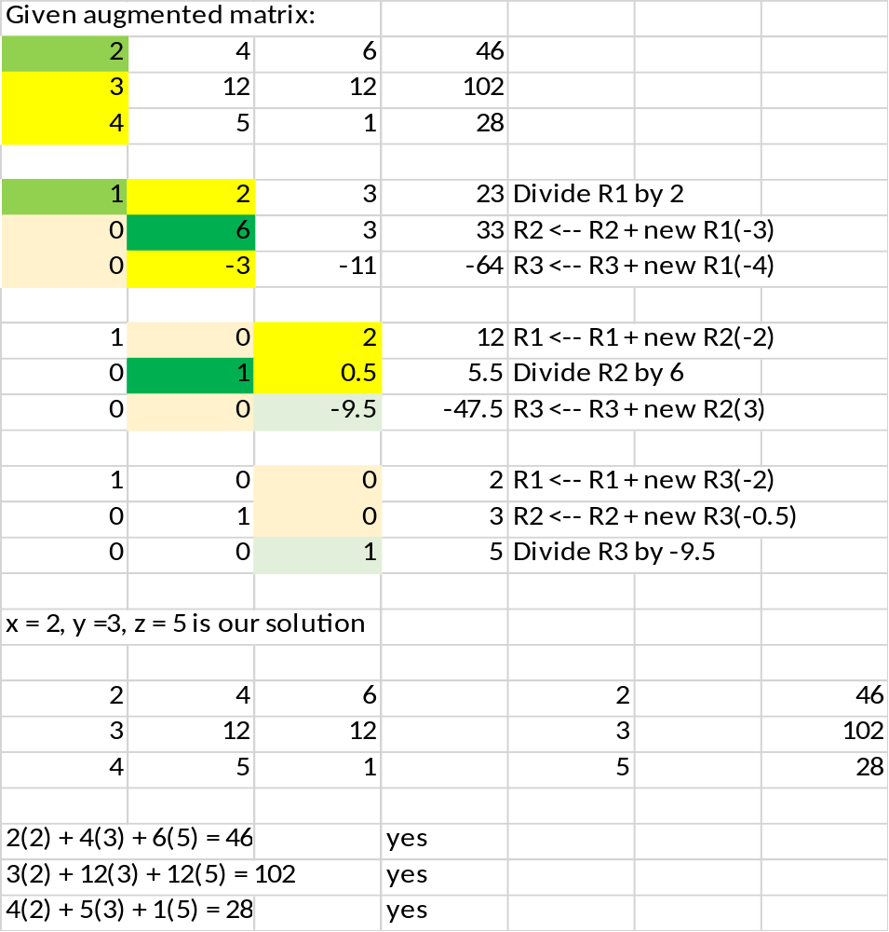
Example 2:
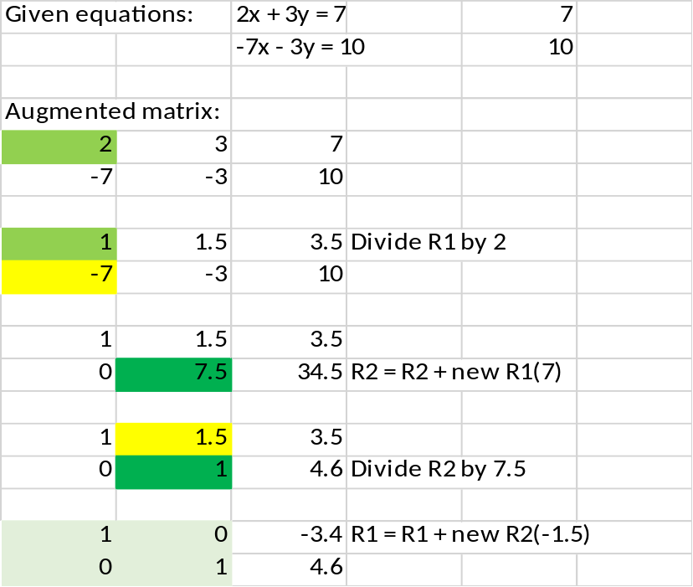
Verify:
2(-3.4) + 3(4.6) = 7 [yes]
-7(-3.4) - 3(4.6) = 10 [yes]

General solution strategy (ignore unsolvable equations for now)
For each row
Reduce the pivot element to 1 (pivot is the element on the diagonal)
Use the pivot element to converts elements in the corresponding column to 0

Algorithm
For each row in the augmented matrix
pivot get pivot for current row (pivot is on the diagonal)
For each element in the current pivot row
current element current element / pivot
For each row in the matrix
If the current row is not the pivot row
dFactor = -1*corresponding element to the pivot in the current row
For each column in the current row
current element current element + dFactor * corresponding element in pivot
Practice:
First practice:
x + y + 2z = 8
-1x - 2y + 3z = 1
3x - 7y + 4z = 10

Second practice:
2x + 2y + 4z = 12
2y + z = 4
2x + y + z = 7

Third practice: (unsolvable)
3x + 2y + 7z = 123
6x + 4y + z = 98
-3x - 2y + 8z = 10

System solvable algorithm
pivot get pivot element for current row
while the pivot is 0
check rows below pivot for a non-zero pivot
if a non-zero pivot is found
swap pivot row with the non-zero row
else
indicate there is no solution
return pivot

Using the Least-Squares Method to Find a Best-Fit Equation
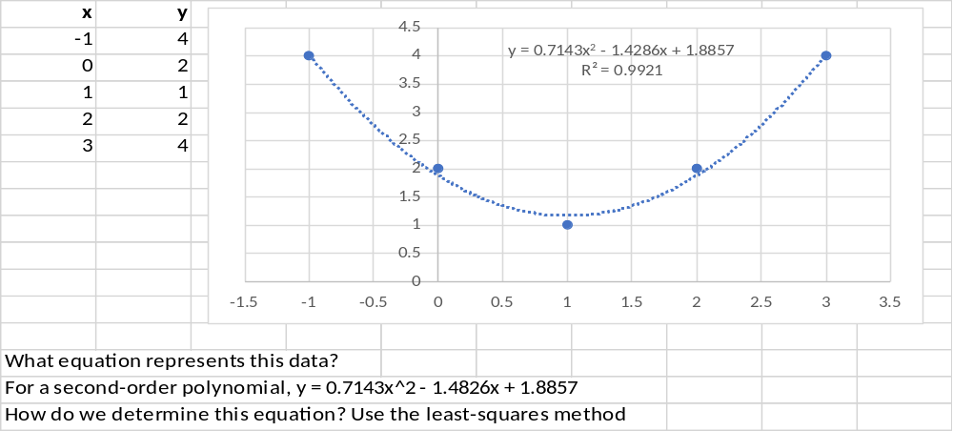
Recall that the general form of a polynomial equation is
$$y=a_{n}x^{n}+a_{n-1}x^{n-1}+…+a_{1}x+a_{0}$$
Examples:
y = 2x^2 + 3x + 1 (degree 2)
y = -3x^3 - 1 (degree 3)
Note that n must be non-negative, is called the degree of the equation
Given a bunch of (x,y) points, we would like to find the coefficients a₀, a₁, a₂, …, a_{n}
We can build a system of linear equations that can be solved to find the coefficients using the formulas below:
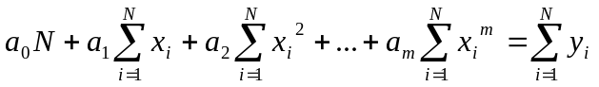
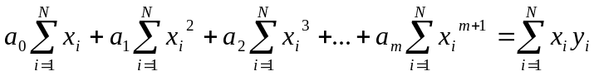
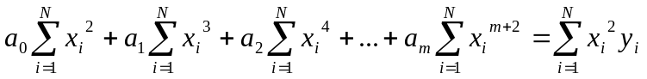
…
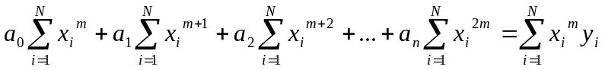

The equations are as above, where:
- m is the degree of the polynomial that we wish to use
- a_{i} are the coefficients of the least-squares equation – they are the values that we wish to find
- N is the number of data points
- x_{i} and y_{i} are the data points
Note the pattern of the equations – with a degree of m, our last equation will start with the sum of the x-values to the m^{th} power and equal the sum of the x-values to the m^{th} power times the y-values.
These equations represent the m + 1 simultaneous equations containing the m + 1 unknown coefficients for the curve that will approximate the experimental data points.

So suppose we want to find an equation of degree 2 for the following data points:
x y x² x³ x⁴ xy x²y
-1 4 1 -1 1 -4 4
0 2 0 0 0 0 0
1 1 1 1 1 1 1
2 2 4 8 16 4 8
3 4 9 27 81 12 36
Total 5 13 15 35 99 13 49
Desired m = 2
N = 5
Sum of the x values = -1 + 0 + 1 + 2 + 3 = 5
Sum of the x² values = (-1)² + 0² + 1² + 2² + 3² = 1 + 0 + 1 + 4 + 9 = 15
etc.
Sum of the y values = 4 + 2 + 1 + 2 + 4 = 13
etc.
So the first equation is 5a₀ + 5a₁ + 15a₂ = 13
The second equation is 5a₀ + 15a₁ + 35a₂ = 13
The third equation is 15a₀ + 35a₁ + 99a₂ = 49
Then solve using Gauss-Jordan elimination (see Excel workbook)

Summary of relationships:
We are given m, the desired degree of the least-squares equation
The number of unknowns = m + 1 (degree + 1)
The number of equations = the number of unknowns = m + 1
The number of x-sums (including N) = 2m + 1
The number of y-sums = m + 1

